Rat in a Maze Report

# Algorithm

Procedure rat_in_maze(MAZE,STACK,TOP,DIR,SOL)

//MAZE(8,13)- 8x13 maze having ‘#’ as walls, ‘ ‘ as empty cell, and ‘O’ as rat initially at (0,0)

//STACK(104,2)- stack to store cell coordinates visited by rat

//TOP- points to location of topmost element in STACK

//DIR(8,2)- array containing all 8 direction coordinates for rat to move

//SOL(8,13)- solution path to exit out of maze. Initially contains only 0s [

STACK(0,0), STACK(0,1) ← 0,0; TOP←0;

SOL(0,0)←1; row, col←0,0;

DIR(0,0), DIR(0,1)←0,1; DIR(1,0), DIR(1,1)←1,0; DIR(2,0), DIR(2,1)←1,1;

DIR(3,0), DIR(3,1)←1,-1; DIR(4,0), DIR(4,1)← -1,0; DIR(5,0), DIR(5,1)← - 1,1;

DIR(6,0), DIR(6,1)← -1,-1; DIR(7,0), DIR(7,1)← 0,-1;

if(MAZE(7,12)==’#’) [

print ‘NO SOLUTION’;

return FALSE;

]

while(TOP!=-1) [

d←0; if(MAZE(7,12)==’O’) [

print ‘SOLUTION FOUND. SOLUTION PATH IS:- ‘;

for i←0 to TOP [

SOL(STACK(i,0), STACK(i,1))←1; print STACK(i,0), STACK(i,1);

]

for i←0 to 7 [

print ‘\n’;

for j←0 to 12 [

print SOL(i,j);

]

]

return TRUE;

]//end if

while(d<8) [

if(valid(row+DIR(d,0),col+DIR(d,1))) [

MAZE(row,col)←'x'; pr←row; pc←col;

row← row+DIR(d,0); col←col+DIR(d,1); MAZE(row,col)←'O’;

TOP←TOP+1; STACK(TOP,0)←row; STACK(TOP,1)←col;

print row,col; break;

]

d←d+1;

]//end d<8

if(d==8) [

MAZE( row, col) ←'X'; pr←row; pc←col;

TOP←TOP-1; row←STACK(TOP,0); col←STACK(TOP,1);

MAZE( row, col) ←'O';

]

print MAZE;

]//end TOP!=-1

print ‘NO SOLUTION’; return FALSE;

]//end procedure

# Working code

#include <stdio.h> #include <unistd.h>

char maze[8][13]={ {'O',' ','#','#','#',' ',' ',' ',' ',' ',' ','#','#'},

{' ',' ',' ','#',' ',' ','#','#','#','#',' ','#','#'},

{'#',' ','#','#','#',' ','#',' ',' ','#',' ',' ','#'},

{'#',' ',' ',' ','#',' ','#',' ',' ','#',' ',' ','#'},

{'#',' ',' ',' ',' ',' ','#',' ','#','#','#','#','#'},

{'#','#','#',' ','#','#','#',' ',' ','#',' ',' ','#'},

{'#',' ','#',' ',' ',' ','#','#',' ',' ',' ',' ',' '},

{'#',' ',' ',' ',' ',' ',' ',' ',' ',' ',' ','#',' '}}; //maze

int stack[104][2]={{0,0}}, top=0; int

sol[8][13]={{1,0,0,0,0,0,0,0,0,0,0,0,0},{0,0,0,0,0,0,0,0,0,0,0,0,0},{0,0,0,0,0,0,0,0,0,0,0,0,0},

{0,0,0,0,0,0,0,0,0,0,0,0,0},{0,0,0,0,0,0,0,0,0,0,0,0,0},{0,0,0,0,0,0,0,0,0,0,0,0,0},

{0,0,0,0,0,0,0,0,0,0,0,0,0},{0,0,0,0,0,0,0,0,0,0,0,0,0}}; //solution matrix

//direction order is right, down, south-east, south-west, up, north-east, north-west, left

int dir[8][2]={{0,1},{1,0},{1,1},{1,-1},{-1,0},{-1,1},{-1,-1},{0,-1}}; //possible directions

int row=0, col=0, pr, pc, end=0; //current and previous coordinates, and program end indicator

void red(){printf("\033[1;31m");} void green(){printf("\033[1;32m");} void

yellow(){printf("\033[1;33m");} void blue(){printf("\033[1;34m");} void

purple(){printf("\033[1;35m");} void cyan(){printf("\033[1;36m");} void screen_clear(void){system("cls");}//function to clear screen

void printMaze()//print maze

{

int i, j; cyan();

printf("%c%c%c%c%c%c%c%c%c%c%c%c%c%c%c\n",176,176,176,176,176,176,176,176, 176,176,176,176,176,176,176);

for(i=0;i<8;i++)

{

cyan();

if(i) printf("%c",176); else printf(" "); //making entrance and left border walls for(j=0;j<13;j++)

{

if(maze[i][j]=='O') yellow(); else if(maze[i][j]=='x') purple(); else if(maze[i][j]=='X') red(); else blue(); //setting color

if(maze[i][j]=='#') printf("%c",219); else if(maze[i][j]=='O') printf("%c",2); else printf("%c",maze[i][j]);

}

cyan();

if(i!=7) printf("%c\n",176); else printf(" \n"); //making exit and right border walls

}

printf("%c%c%c%c%c%c%c%c%c%c%c%c%c%c%c\n",176,176,176,176,176,176,176,176, 176,176,176,176,176,176,176);

}

int valid(int r, int c) //for checking if move is valid(r,c are next coordinates; row,col are current; pr, pc are previous coordinates)

{

if(r>=0 && r<8 && c>=0 && c<13 && maze[r][c]!='#' && maze[r][c]!='x' && maze[r][c]!='X' && !(pr==r && pc==c)) return 1;

return 0;

}

void move()

{

int i,j,k, d=0;

if(maze[7][12]=='O') //rat reached exit

{

green(); printf("\n\nSolution found\n\nSolution path:\n"); yellow(); for(i=0; i<=top; i++)

{

j=stack[i][0]; k=stack[i][1]; sol[j][k]=1;

printf("(%d,%d)\n",stack[i][0],stack[i][1]);

}

for(i=0;i<8;i++)

{

printf("\n"); for(j=0;j<13;j++)

{

if(sol[i][j]==0) yellow(); else green();

printf("%d ",sol[i][j]);

}

}

end=1; return;

}

//moving conditions

if(top==-1){ end=1; return; }//if no move possible then end while(d<8)

{

if(valid(row+dir[d][0],col+dir[d][1]))

{

maze[row][col]='x'; pr=row; pc=col;

row=row+dir[d][0]; col=col+dir[d][1]; maze[row][col]='O'; top++; stack[top][0]=row; stack[top][1]=col; printf("\n\nGoing to (%d,%d)",row,col);

break;

}

d++;

}

if(d==8) //no free cell so backtrack

{

maze[row][col]='X'; pr=row; pc=col; printf("\n\nBacktracking from (%d,%d)",pr,pc);

top--; row=stack[top][0]; col=stack[top][1]; maze[row][col]='O';

}

sleep(1); //to slow down rapid screen clearing I'm giving it a delay of 1 second screen_clear(); printMaze();

}

int main()//main function

{

screen_clear(); //if I remove it then colors won't work

printMaze(); //initial maze

if(maze[7][12]=='#') //blocked exit

{

red(); printf("\nNo solution"); return -1;

}

while(end!=1) move(); //start moving

if(maze[7][12]!='O'){ red(); printf("\nNo solution"); } //rat didn't reach exit

return 0;

}

# Output

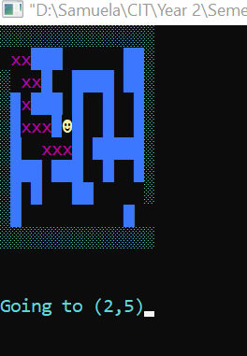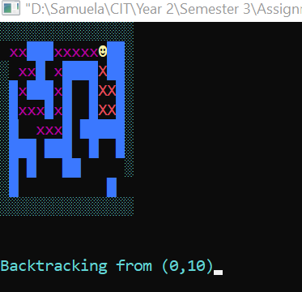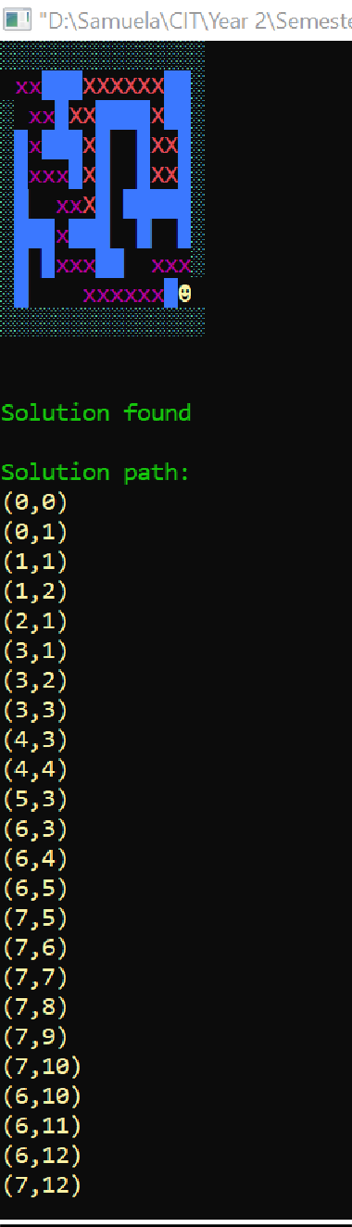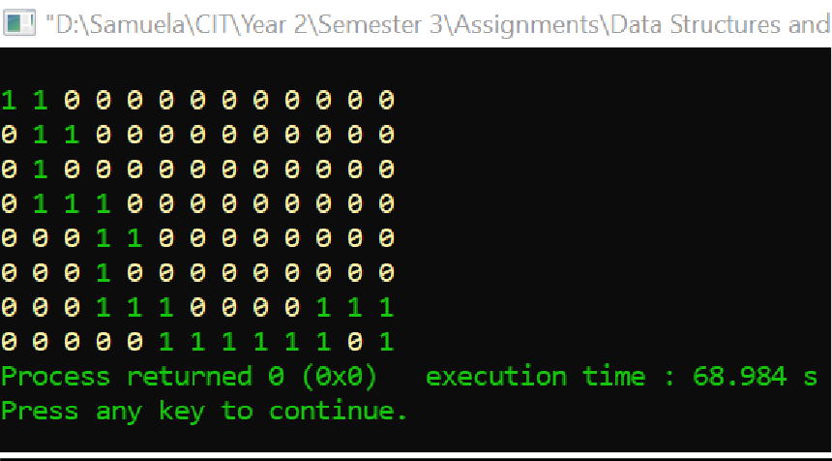

**No solution case-**

